Technical Design Document
Project Name: Loan Application
Project by:
Dinesh
Introduction
Loan Application is created to allow the user to do the bank related functions in a span of few minutes such as check balance, apply for the loan, pay the EMI, calculate EMI for some loan amount and also print the transactions.
Functional Requirements:
The functional requirements of the project are:
- Login
- Sign Up
- Check Balance
- Add Balance
- Payment
- Calculate EMI
- Apply Loan
- Pay EMI
- Fore Close Account
- Transactions
Functions:
The different functions in which this project is divided into are:
Check Balance: Check user balance and also add more money to the existing account
Calculate EMI: Calculate the monthly for different loan amount and duration
Apply Loan: Apply for the loan and also calculate respective monthly EMI
Pay EMI: Pay the monthly EMI for the loan.
Fore Close Account: Fore close the account the paying the required loan amount.
Transactions: Print the transactions which will generate in time of pay EMI and adding balance.

Overall Architecture Diagram:

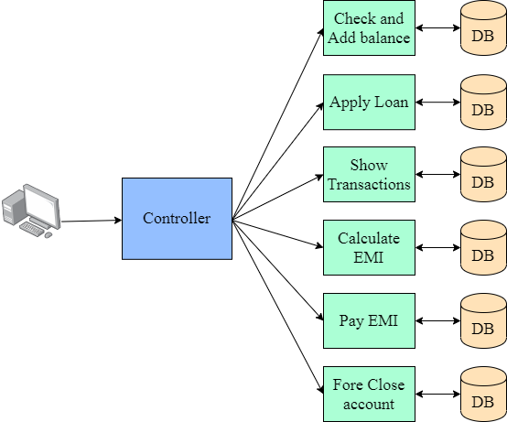

Overall Entity Relationship Diagram:
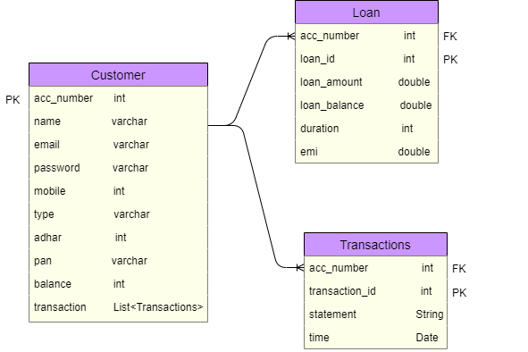

Class Diagram:
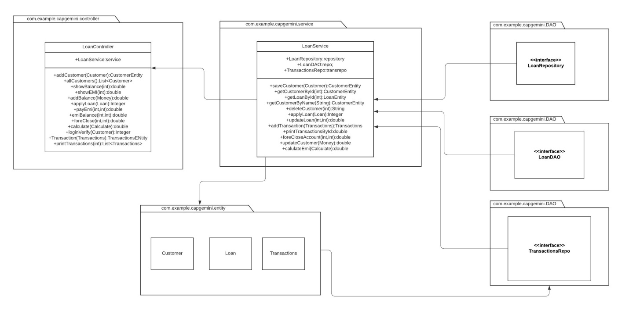

Sequence Diagrams:

Login-

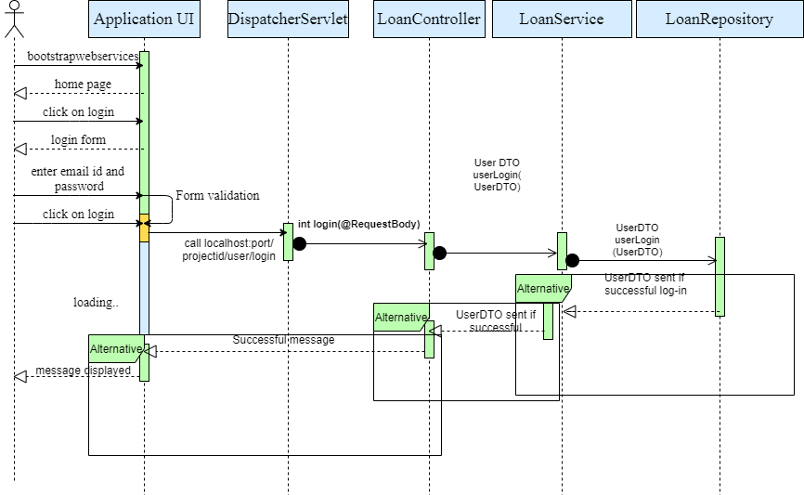

Registration of new customer-

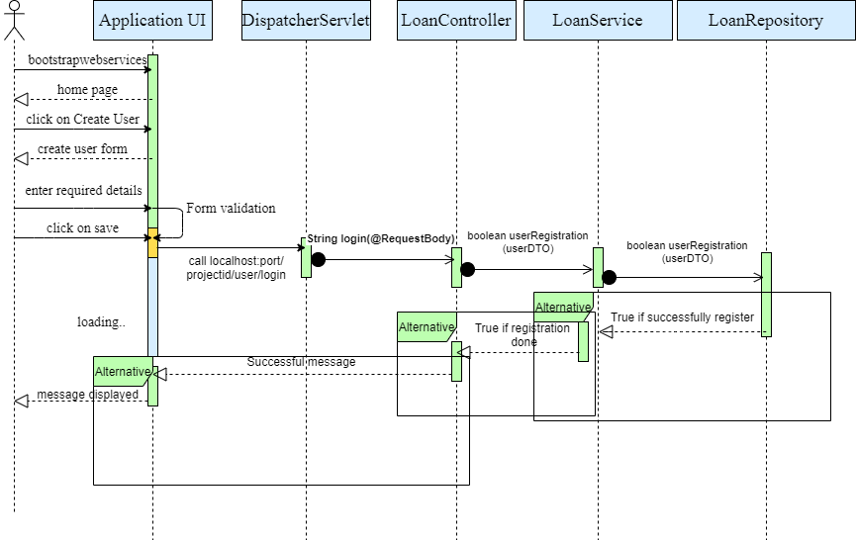

Functions-
1) Customer details
2) Add balance
3) Apply for the loan
4) Pay EMI
5) Calculate EMI
6) Print transaction
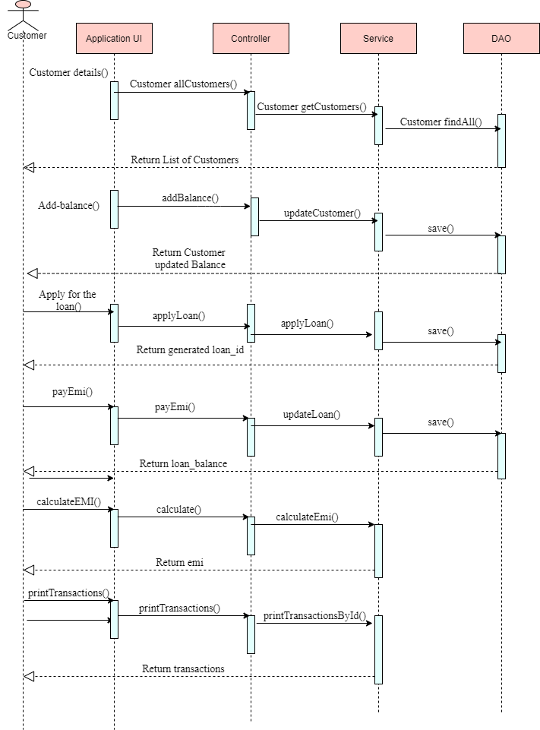
7) Add Transaction
8)Fore Close account
9) EMI balance

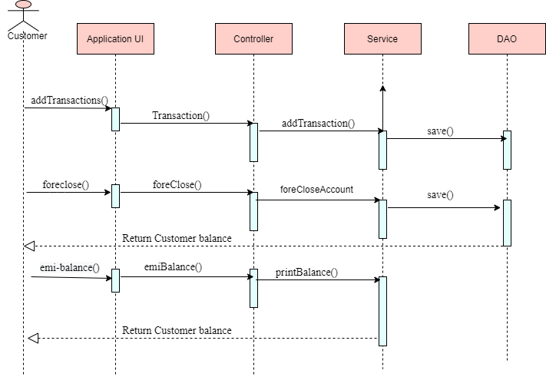

Activity Diagrams:
Login-
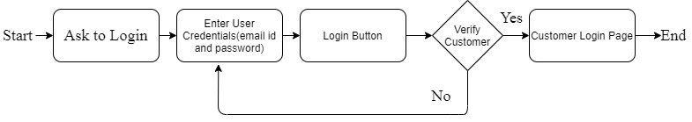
Registration-

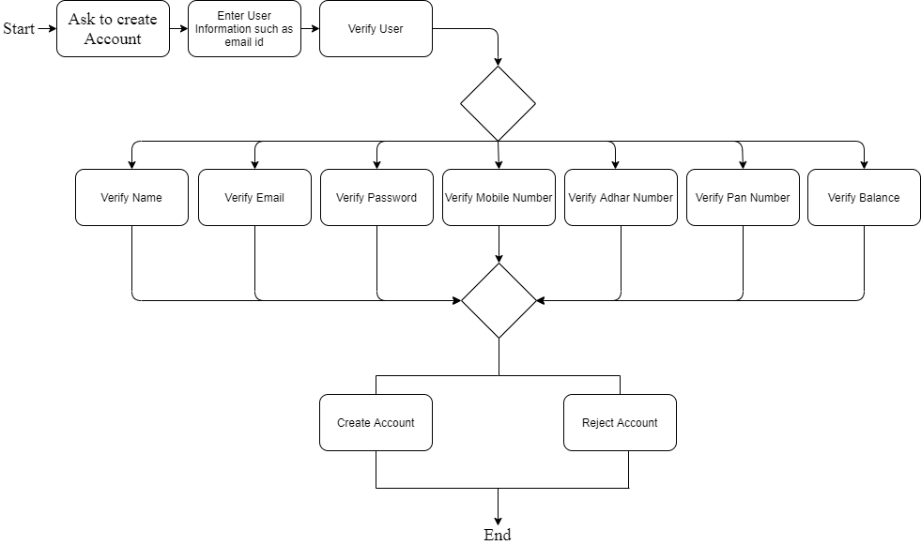
Check Balance-

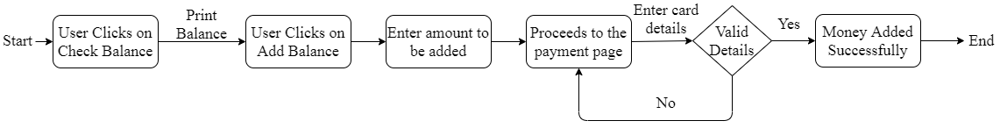
Apply Loan-
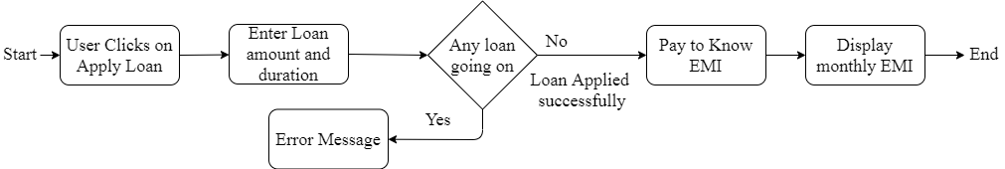
Print transactions-

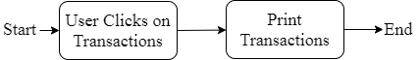

Calculate EMI-

Pay EMI-

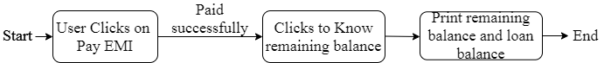

Fore Close-

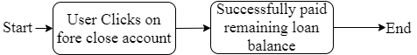
WireFrames-
1) Log In

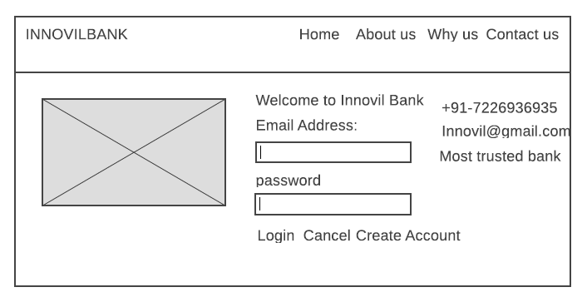
2) Sign Up
